**SSH to your AWS Workstation**

**ssh devops@<public-ip-addr**> of your Workstation  
Password is : **Dev0p$!!/**

**Replace <your-name> with your name throughout the lab.**

1. Run the below commands on your AWS-Workstation

|  |
| --- |
| $ mkdir /home/devops/application  $ cd /home/devops/application  $ curl -f <https://pastebin.com/raw/4ymZFiyp> > dotnet_app-<your-name>.yaml |

2. Edit the **dotnet_app-<your-name>.yaml**

|  |
| --- |
| $ vim dotnet_app-<your-name>.yaml |

Update the image: **lovescloud/docker-dotnet:latest** with your Docker Hub image name that you uploaded to docker hub in Docker Lab Pushing images to docker Hub for dotnet.

Replace <your-name> with your namein the above script.

**Save and exit by pressing the ESC Key and type :wq to save and quit by pressing enter**

3. Run the below commands to deploy the .NET application on your Kubernetes Cluster

|  |
| --- |
| $ kubectl apply -f dotnet_app-<your-name>.yaml -n <your-name> |

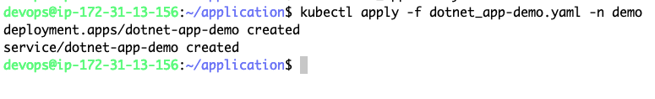

4. Check the **NODE** where your app has been deployed.

|  |
| --- |
| $ kubectl get po -o wide -n <your-name> |



In this example the app has been deployed to the NODE **gke-devops-default-pool-b94ad320-9dtl**

5. Check the **NODEPORT** on which your dotnet app has been exposed.

|  |
| --- |
| $ kubectl get svc -n <your-name> |

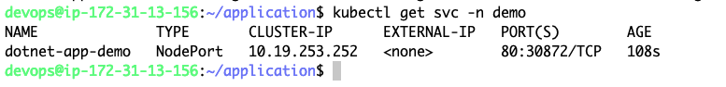

**Example**

**I**n this example the albert dotnet application has been exposed on port **30872** as shown above.

6. Check the public IP of the NODE (**gke-devops-default-pool-b94ad320-9dtl**) to access the dotnet application web page from the NODE Public IP address and Node Port on which it is exposed at.

|  |
| --- |
| $ kubectl get nodes -o wide |

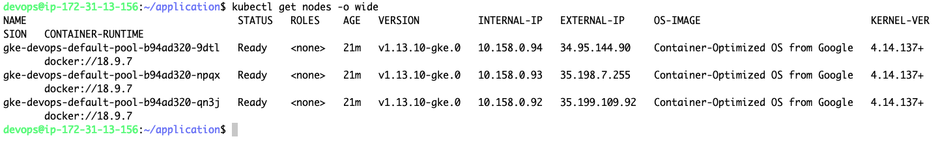

The public IP for the NODE **gke-devops-default-pool-b94ad320-9dtl** is **34.95.144.90** and the NodePort on which the app has been exposed is **30872** as obtained in step 5.

**7. Access the application from the public IP of the NODE and the NodePort as shown below.**

**http://<NODE-PUBLIC-IP>:NODEPORT**

[**http://34.95.144.90:30872/**](http://34.95.144.90:30872/)

